
Dashboard Design

Date | 02 November 2026
Team ID | NA
Project Name | Electric Vehicle Market Performance & Insights
Maximum Marks | 5 Marks

Creating an effective dashboard involves thoughtful design to ensure that the presented information is clear, relevant, and easily understandable for the intended audience. Here are some key principles and best practices for dashboard design
Activity 1: Interactive and visually appealing dashboards
Creating interactive and visually appealing dashboards involves a combination of thoughtful design, effective use of visual elements, and the incorporation of interactive features. Here are some tips to help you design dashboards that are both visually appealing and engaging for users so take care of below points
- Clear and Intuitive Layout
- Use Appropriate Visualizations
- Colour and Theming
- Interactive Filters and Slicers
- Drill-Down Capabilities
- Responsive Design
- Custom Visuals and Icons
- Use of Infographics

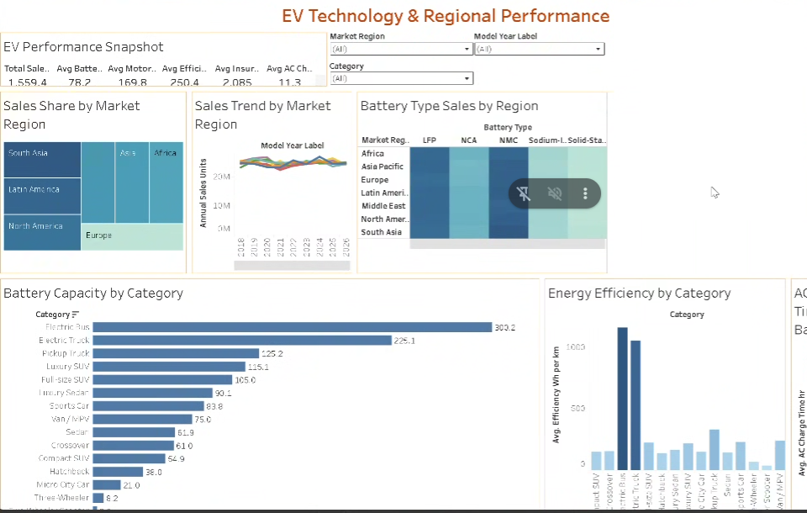
Key outcomes of the EV Technology Dashboard:
Five main outcomes:
- Balanced global demand: Every market region holds about 14% of sales, and regional trends move together across 2018–2026.
- NMC and LFP lead in every region: The heatmap shows NMC and LFP are the top battery types everywhere; Sodium-Ion and Solid-State remain small.
- Heavy vehicles need big batteries: Electric Buses (300.2 kWh) and Trucks (225.1 kWh) have the largest batteries and also use the most energy per km (over 1,000 Wh/km).
- Charging time is similar for all chemistries: AC charging takes about 11.3 hours on average whatever the battery type.
- Headline figures: 1,559.4 M annual units, 78.2 kWh average battery, 169.8 kW motor, 250.4 Wh/km, 2,085 USD yearly insurance.
Overall: sales are balanced across regions, NMC and LFP dominate everywhere, heavy vehicles need the largest batteries and the most energy per km, and charging time depends on battery size rather than chemistry – answering the questions of Emily, David and Sarah.

Activity 2
Publish Dashboard on Tableau Public and Paste the Dashboard Public link below:
Dashboard public link:
https://public.tableau.com/app/profile/riya.sharma8766/viz/ev_riya_final/EVTechnologyDashboard

